SpendWise
A Simple Backend Learning Project
Node.js · Express · MongoDB · JWT Authentication
Project Documentation | Version: v1.0 | Date: 8 March 2026 | Team ID: SWTID-2026-1005

1. Project Overview
SpendWise is a backend application designed to help beginner developers build secure REST APIs using Node.js, Express, MongoDB, and JWT authentication. The project demonstrates user authentication, complete CRUD operations on personal records, and how protected routes are enforced using middleware — all within a clean, modular, beginner-friendly architecture.

1.1 Key Objectives
▸ Provide secure user authentication using JSON Web Tokens (JWT)
▸ Enable complete CRUD operations on user-owned transaction records
▸ Demonstrate MongoDB integration using Mongoose ODM
▸ Illustrate how protected routes are enforced using Express middleware
▸ Maintain a simple, modular, and beginner-friendly backend architecture

1.2 Target Users
Target User | Learning Goal
Beginner Backend Developers | Learning to build their first secure REST API from scratch
Students (Node.js / Express) | Looking for a guided, structured, hands-on project
Freshers / Interview Prep | Wanting a portfolio project demonstrating JWT & MongoDB skills
Self-Learners | Seeking a clean reference architecture for REST API development

2. Project Setup & Prerequisites
2.1 Quick Start
# 1. Initialise the project
npm init

# 2. Install all dependencies
npm install express mongoose jsonwebtoken bcrypt cors dotenv

# 3. Start the development server
npm run dev

# API is available at:
http://localhost:5000

2.2 Step-by-Step Setup
▸ Create or navigate to your project directory in the terminal
▸ Initialise a Node.js project using npm init
▸ Install required packages: express, mongoose, jsonwebtoken, bcrypt, cors, dotenv
▸ Create folders: models, routes, controllers, middleware, config
▸ Create server.js at the root and a .env file with PORT, MONGO_URI, JWT_SECRET
▸ Start the server using npm run dev — test APIs at http://localhost:5000

2.3 Software Requirements
Software | Purpose
Node.js | JavaScript runtime for backend execution
MongoDB | NoSQL database for persistent data storage
npm | Node package manager for dependency management
Git | Version control system
VS Code | Recommended code editor

2.4 Knowledge Requirements
▸ JavaScript ES6+ (arrow functions, async/await, destructuring)
▸ Node.js and Express.js fundamentals
▸ MongoDB and Mongoose ODM
▸ JWT (JSON Web Token) authentication flow
▸ Basic REST API concepts (HTTP methods, status codes, routes)
▸ Git basics (clone, commit, push)

3. Technical Architecture
3.1 Architecture Diagram
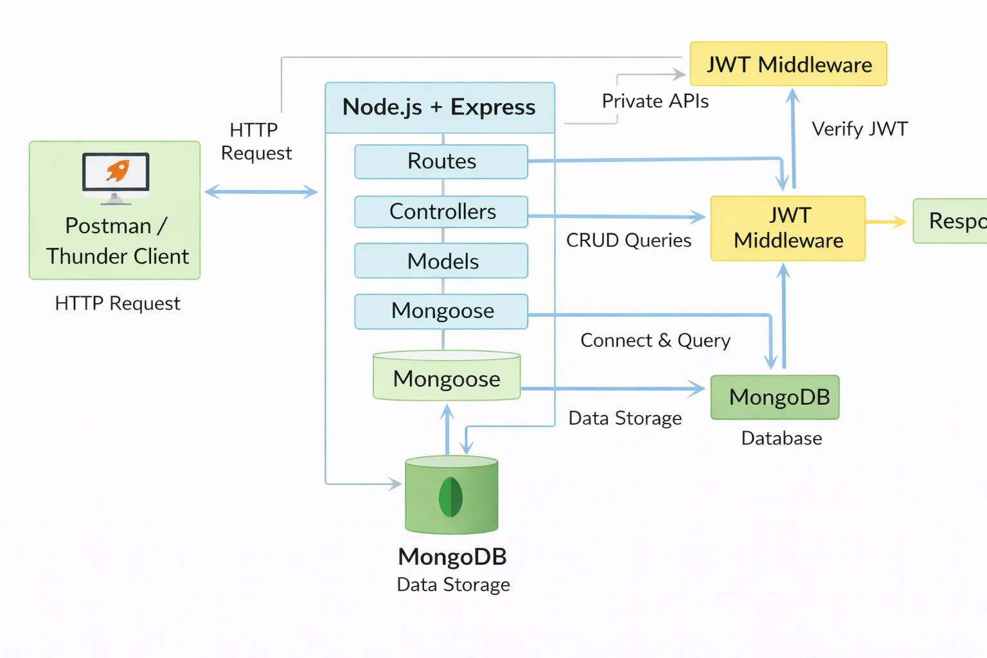
Figure 1 — SpendWise Backend Architecture Diagram

3.2 Backend Layer Breakdown (Node.js + Express)
Layer | Responsibility
Controllers | Handle business logic for authentication and CRUD operations
Models | Mongoose schemas defining User and Transaction data structures
Routes | API endpoint definitions for auth and all CRUD operations
Middleware | JWT token verification and request protection layer
Config | Database connection setup and environment variable management

3.3 ER Diagram
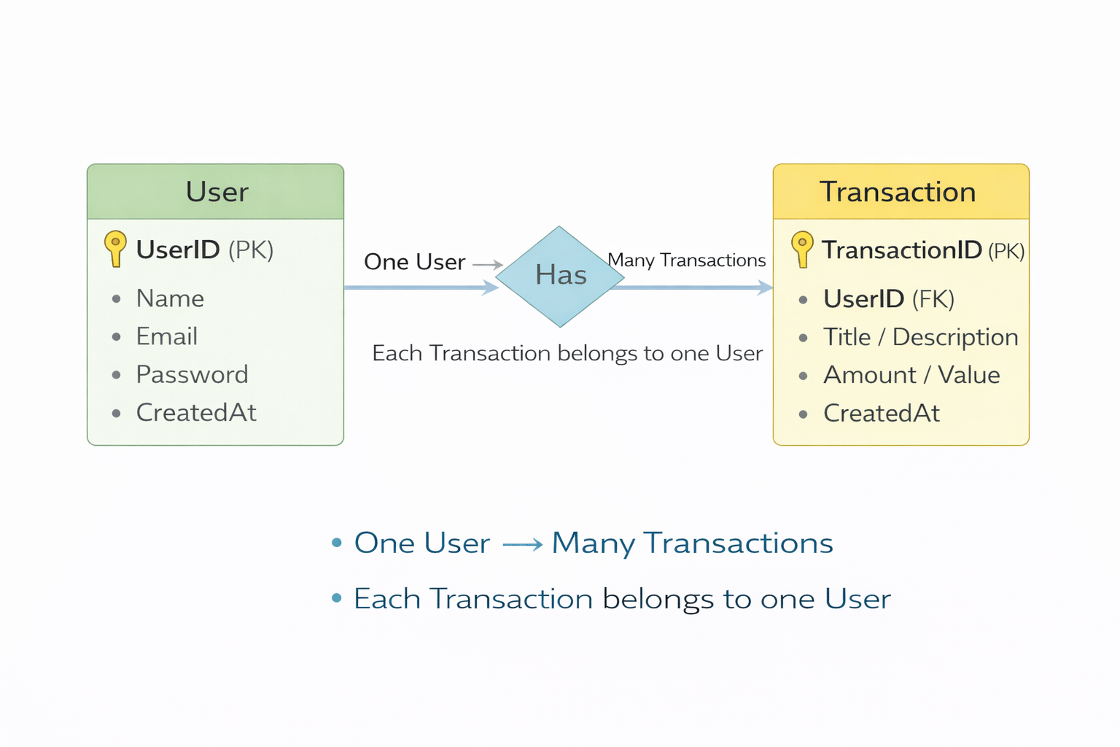
Figure 2 — Entity Relationship Diagram (Users ↔ Transactions)

3.4 Database Schema (MongoDB)
Collection | Fields
Users Collection | _id, name, email, password (hashed), createdAt
Transactions Collection | _id, userId (FK), title, description, amount, createdAt
Relationship | Many Transactions belong to One User — userId as foreign key reference

4. Features
# | Feature | Description
01 | User Authentication | JWT-based secure registration and login flow with password hashing
02 | CRUD Operations | Create, Read, Update, and Delete on user-owned transaction records
03 | Protected Routes | Middleware-enforced JWT verification on all private API endpoints
04 | MongoDB Integration | Persistent data storage and retrieval using Mongoose ODM

5. Roles & Responsibilities
Role | Responsibilities
Student / Developer | Write backend code, define API routes, test endpoints using Postman or Thunder Client, push code to GitHub
Backend System | Authenticate users via JWT, process CRUD operations, store and retrieve data from MongoDB, protect private routes via middleware

5.1 User Flow Diagram
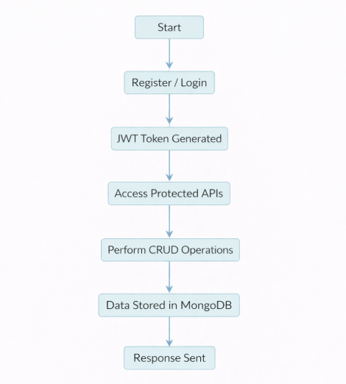
Figure 3 — End-to-end User Flow (Registration → Login → CRUD Operations)

6. Project Configuration
6.1 Folder Structure
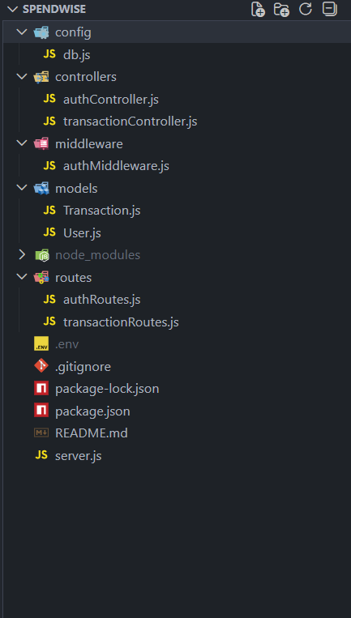
Figure 4 — SpendWise Project Folder Structure

6.2 Environment Configuration (.env)
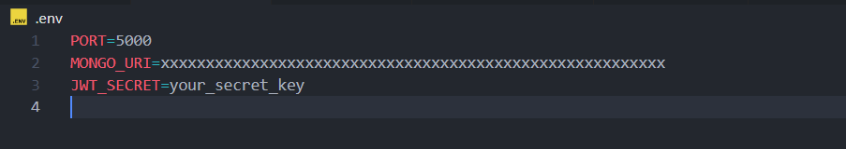
Figure 5 — .env file with PORT, MONGO_URI, and JWT_SECRET

6.3 Database Connection (config/db.js)
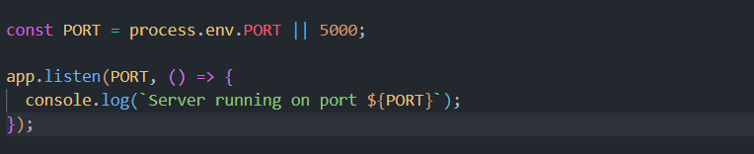
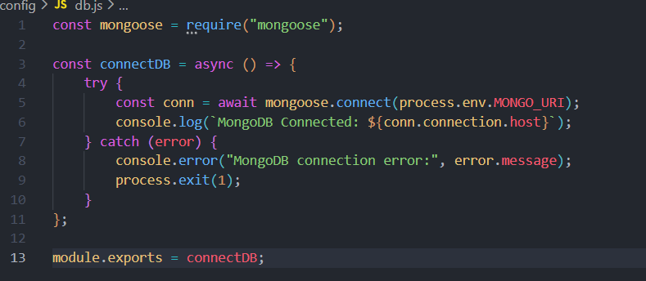
Figure 6 — Mongoose connection with success and error handling

7. Backend Development
7.1 Development Checklist
Step | Task | Details
Step 1 | Express Server | Initialise Express app, configure cors and express.json middleware, define PORT in .env
Step 2 | Environment Config | Create .env file with PORT, MONGO_URI, and JWT_SECRET variables
Step 3 | Database Connect | Create config/db.js, connect via mongoose.connect(), handle success and error callbacks
Step 4 | Data Models | Define User schema (name, email, hashed password) and Transaction schema (userId, title, amount, timestamps)
Step 5 | Auth Routes | POST /api/auth/register — hash password, save user; POST /api/auth/login — verify credentials, return JWT
Step 6 | CRUD Routes | GET, POST, PUT, DELETE on /api/records — all protected by auth middleware
Step 7 | Auth Middleware | Verify JWT from Authorization header; return 401 if missing or invalid
Step 8 | Error Handling | Wrap all controllers in try/catch; return descriptive messages with appropriate HTTP status codes

7.2 Auth Routes (routes/auth.js)
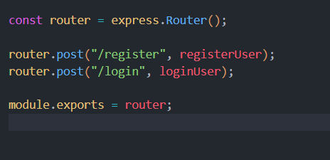
Figure 7 — Auth route definitions for Register and Login

7.3 User Schema (models/User.js)
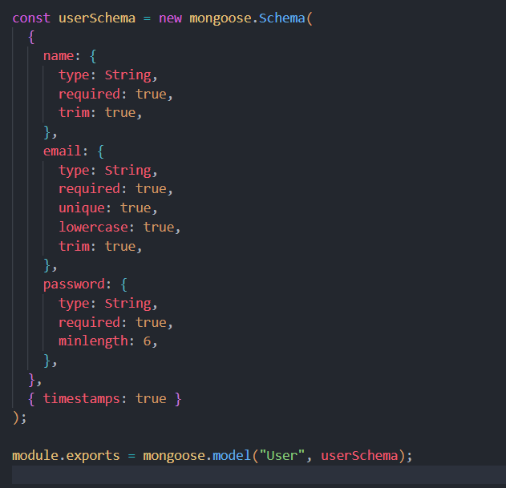
Figure 8 — Mongoose User schema with hashed password field

7.4 Transaction Schema (models/Transaction.js)
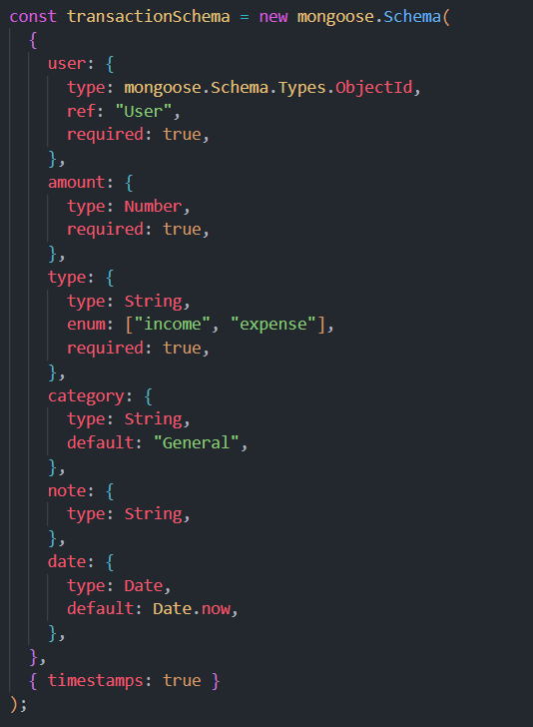
Figure 9 — Mongoose Transaction schema with userId reference

8. Project Execution
8.1 Execution Steps
# | Step | Description
01 | Start MongoDB | Start local MongoDB instance or connect to Atlas using the URI stored in .env
02 | Run Backend Server | Execute npm run dev — server starts at http://localhost:5000
03 | Test Register API | POST /api/auth/register with name, email, password — expect 201 Created response
04 | Test Login API | POST /api/auth/login with email, password — expect JWT token in response body
05 | Copy JWT Token | Copy the returned token to use as Bearer token in all subsequent requests
06 | Access Protected APIs | Add Authorization: Bearer <token> header to all CRUD endpoint requests
07 | CRUD Operations | Test Create, Read, Update, Delete on /api/records using the JWT token

8.2 Server Start
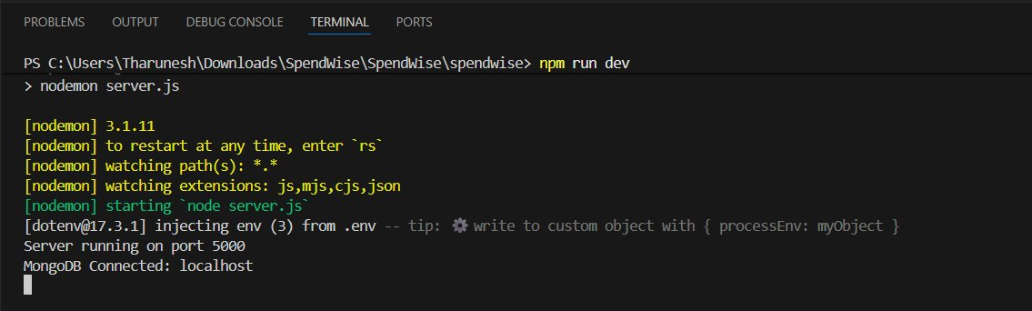
Figure 10 — Server running on port 5000 with MongoDB connected

9. Output Screenshots
The following screenshots demonstrate each API endpoint tested via Postman.
9.1 Register API — POST /api/auth/register
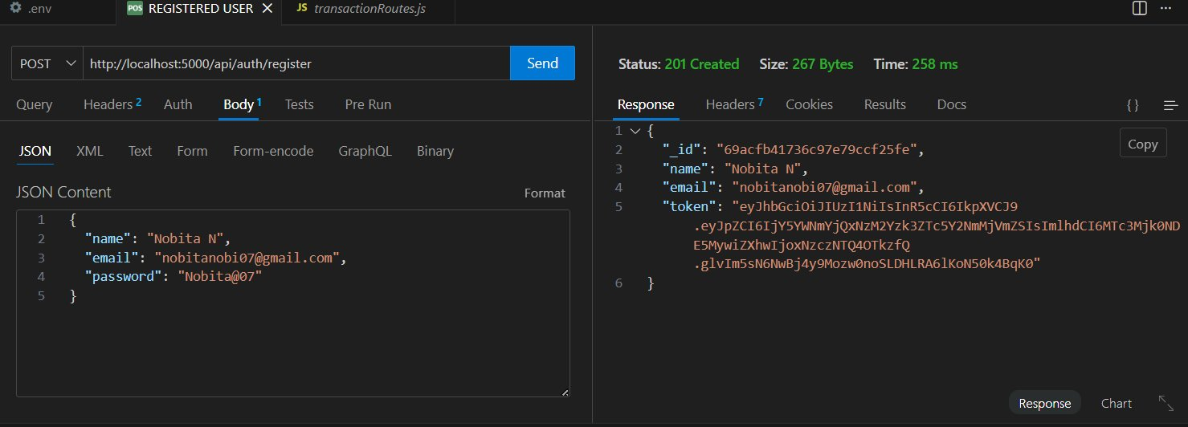
Figure 11 — 201 Created response with user object and JWT token on registration

9.2 Login API — POST /api/auth/login
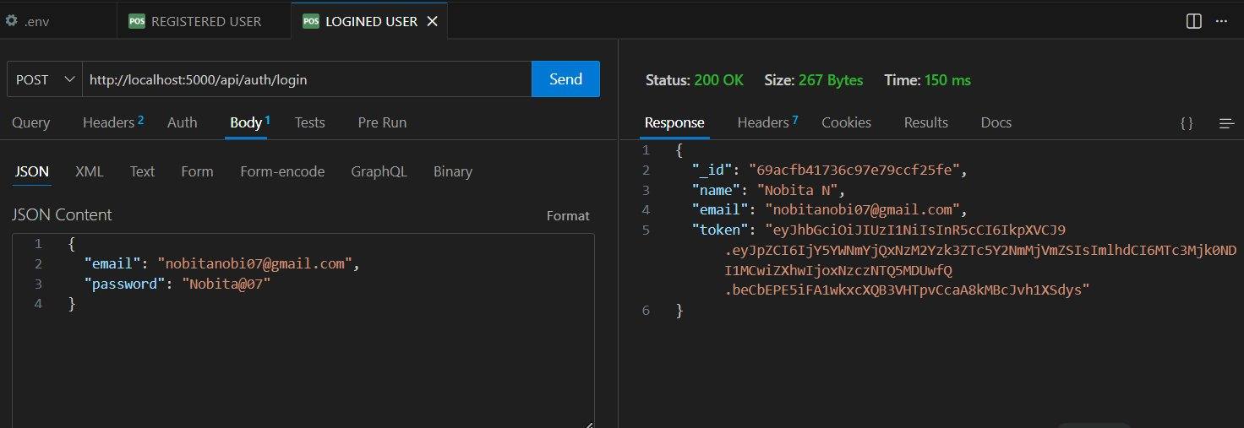
Figure 12 — 200 OK response with JWT token returned on successful login

9.3 JWT Token
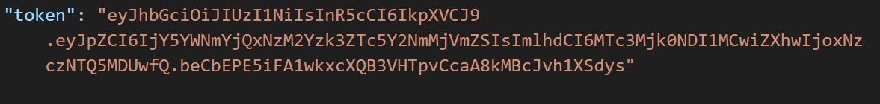
Figure 13 — JWT token from login response, used as Bearer token for protected requests

9.4 Create Transaction — POST /api/transactions
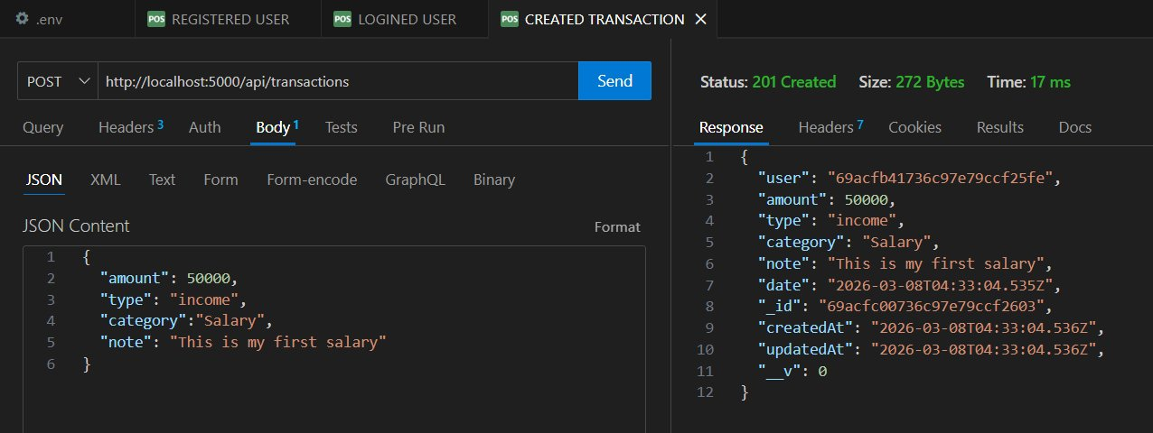
Figure 14 — 201 Created response with new transaction record persisted in MongoDB

9.5 Get Records — GET /api/transactions
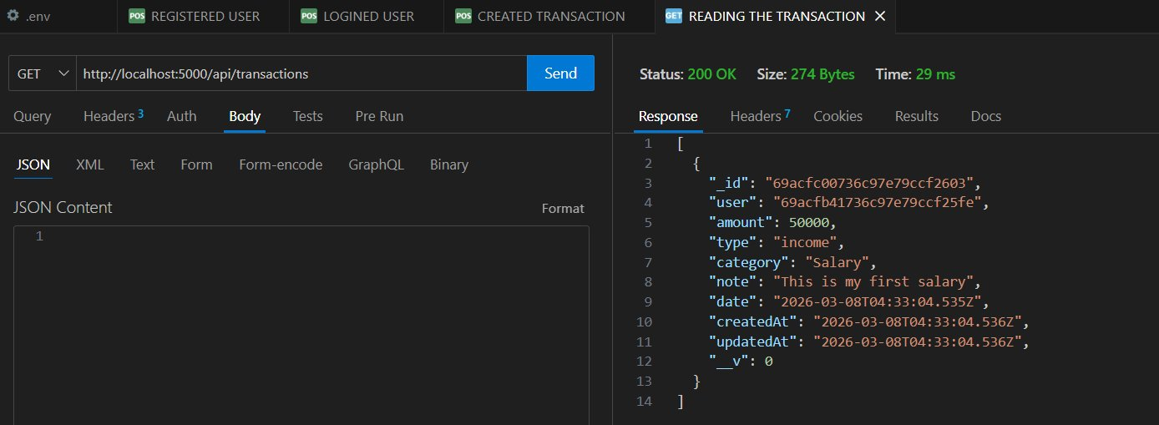
Figure 15 — 200 OK response returning all transactions for the authenticated user

9.6 Update Record — PUT /api/transactions/:id
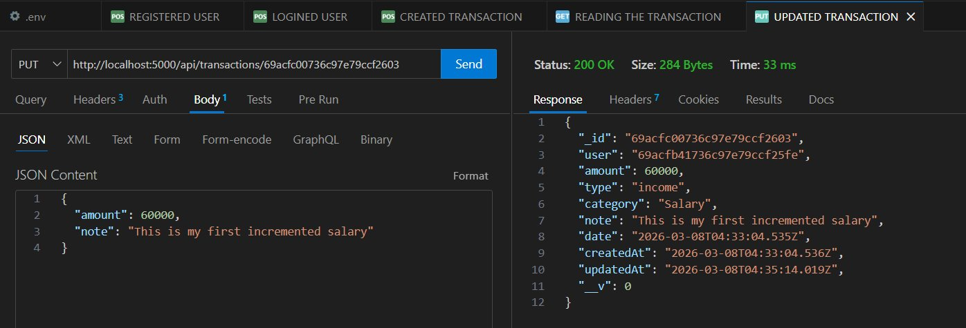
Figure 16 — 200 OK response confirming updated transaction fields in MongoDB

9.7 Delete Record — DELETE /api/transactions/:id
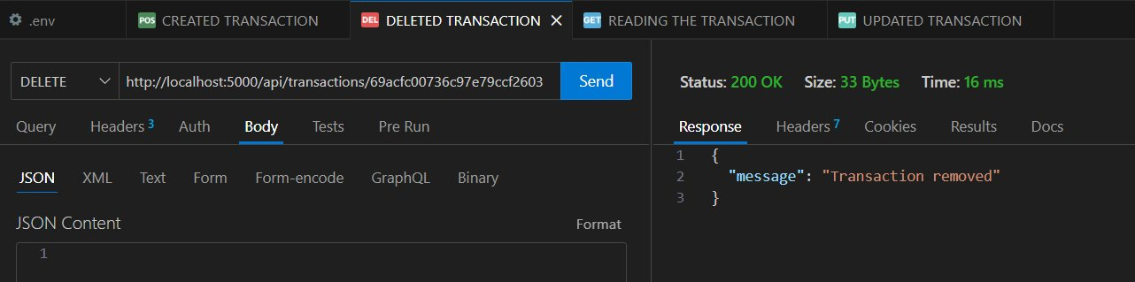
Figure 17 — 200 OK with 'Transaction removed' confirming successful deletion

